Link: <https://crackmes.one/crackme/5b81014933c5d41f5c6ba944>

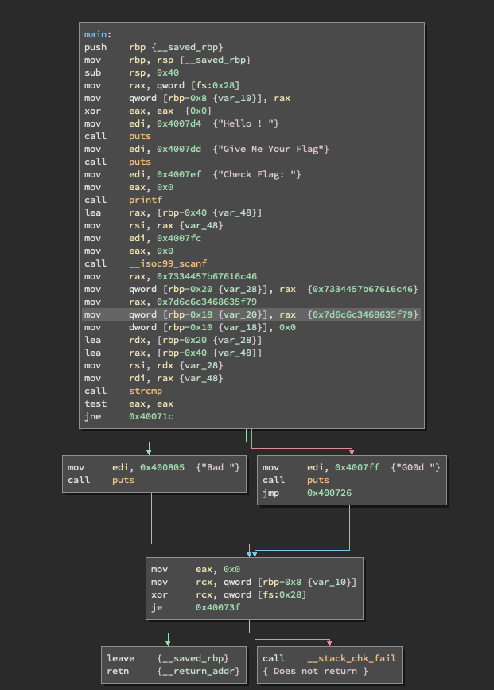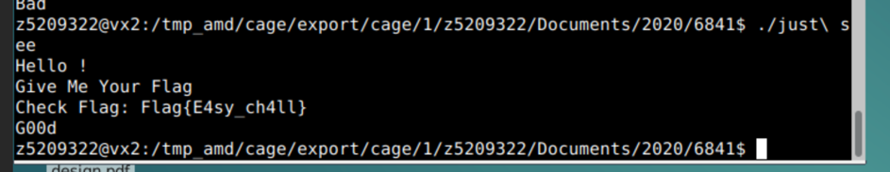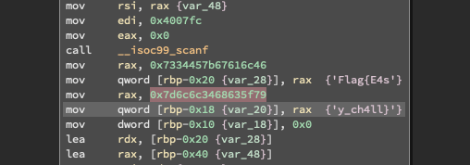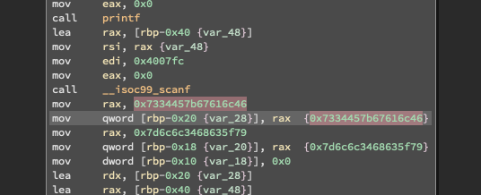This was a fairly simple one. I ran the program and it asked for a flag. I then opened the disassembled code and found it was comparing to extremely large addresses. But they were not addresses, but a string when viewed as character constants.